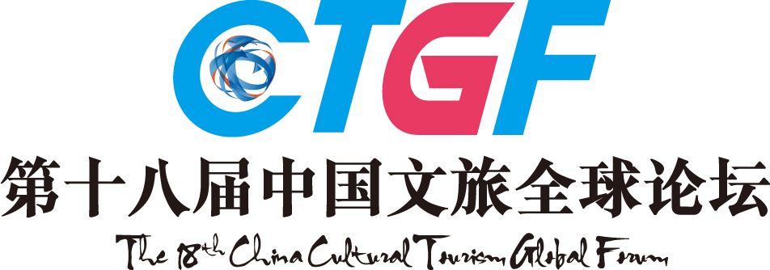

2017 - 2018
THE 18TH CHINA HOTEL GOLDEN HORSE AWARD
Awards List (Catering)
Applicant:_____________________________________________
Catering Awards | Catering Management Group & Catering Group (2017- 2018)：  □Most Favored International Catering Group  □Most Favored National Catering Group  □Most Potential Catering Group /Management Company of China  □Most Influential Listing Catering Company of China  □Top 10 Famous Catering Management Companies of China  □Most Influential Catering Group  □Best CSR Group/Management Company of China Catering Industry  □Catering O2O Innovation Model Enterprise of China  □Catering “Internet Plus” Landmark Enterprise of China  □Best Employer of China Catering Industry  Other Ad Hoc Title:_____________________________________________
Catering Awards | Brand Awards(2017- 2018)  □Leading Brand of China Cuisines (Only One Award in Each Branch) □  □Top 10 Well-known Food Brands of China  □Most Favored Star Food Brand by Customers  □Most Valuable Investment Catering Brand of China  □Nova Catering Brand of China  □Creative Catering Brand of China  Other Ad Hoc Title:_____________________________________________
Catering Awards | Restaurants(2017- 2018)  (1) A Bite of China Style Awards（Or Apply for Other Ad Hoc Titles According to Your Own Characteristics)  □A Bite of China Sichuan Cuisine Famous Restaurant  □A Bite of China Cantonese Cuisine Famous Restaurant  □A Bite of China Hunan Cuisine Famous Restaurant  □A Bite of China Legacy Award  □A Bite of China Creativity Award □Others___  (2) The Supreme Awards （Or Apply for Other Ad Hoc Titles According to Your Own Characteristics)  □The Supreme Seafood □The Supreme Abalone  □The Supreme Sea Cucumber □The Supreme Sushi  □The Supreme Wedding Banquet □The Supreme Banquet  □The Supreme Joyful Banquet □The Supreme Western Food  □The Supreme Hot-pot  (3) Best Restaurants of China (Top 100 Restaurants)  □Most Favored Chinese Restaurant by International Travelers  □Most Favored Chinese Tea Restaurant Brand by International Travelers  □Best International Restaurant of China  □Most Competitive Restaurant of China  □Best Wedding Banquet Restaurant of China  □Best Business Banquet Restaurant of China  □Best Innovative Design Restaurant of China  □Most Fashionable Restaurant of China  □Best Creative Cuisine Restaurant of China  □Best Theme Restaurant of China  □Most Glamorous Style Restaurant of China  □China’s Most Favored Star Restaurant by Customers  □Best Health Diet Restaurant of China  □Best Flavor of Public Restaurant of China  □Best Cantonese Restaurant of China  □Best Teochew Restaurant of China  □Best Korean Restaurant of China  □Best Japanese Restaurant of China  □Best Southeast Asian Restaurant of China  □Best Halal Restaurant of China  □Best Western Restaurant of China  □Best Landscape Restaurant of China  □Best Service Restaurant of China  □Best Newly-opened Restaurant of China  Other Ad Hoc Title:_____________________________________________
Catering Awards | Figure Awards (2017- 2018)  - China Hotel Elites List---Top 100 Influential Figures of the Year  □Lifetime Achievement Honor □Five-star Elite  □Platinum Elite □Top 10 Prominent Figures of China Hotel Industry of the Year  (2) Comprehensive Award (2017- 2018)  □Healthy Food Promotion Ambassador of China  □“Eating in China” Culture Promotion Ambassador of China  □Planning Master of China Catering Industry  □Creative Master of China Catering Industry  □Internet Marketing Master of China Catering Industry  □Management Master of China Catering Industry  □Platinum Professional Manager in China Catering Industry  □Top 10 Chefs of China □Golden Spoon Chef of China  □Platinum Chef of China □Golden Chef of China  Other Ad Hoc Title:_____________________________________________
Catering Awards | Dishes Awards (2017- 2018)  □Famous Chinese Cuisine □Famous Chinese Snack □Famous Chinese Dim-sum  Other Ad Hoc Title:_____________________________________________
Note：Please mark “√” in the form to select the award you want to apply for.

The 18th China Hotel Industry Golden Horse Awards Ceremony

Inspired by the excellent China Tourism City logo, which is a horse stepping on a flying swallow, China Hotel Golden Horse Award chooses the same image as the award shape to symbolize the highest honor of China Hotel Industry, initiated by Mr. Liu Yi, former Director of National Tourism Administration. With 18 years of continuous influences, China Hotel Golden Horse Award has gained wide recognition and high reputation, and the winner of which would be regarded as the benchmark of the industries.

Still referring the international selection tradition, the 18th China Hotel Golden Horse Awards will be selected and produced from the finalists of cultural tourism & Hotels, top 100 catering enterprises, top 100 partners of 2017-2018(including manufacturers, service providers, suppliers, hotel design agencies) of industry chain, China featured tourism towns, boutique hotels, ecological farms, as well as Top 100 Influence Elites of China Hotel Industry of 2017-2018. For individuals or enterprises that meet the above requirements, please submit application materials and the application form (see the attachment).

Key Dates for the Award
Submission: From October 9th, 2017
Awards Announcement: March 22nd, 2018
Award Ceremony: March 22nd, 2018

4. The Selection Process
Stage 1: Nominee Recommendation
The nominees are recommended by their governmental competent departments. Taking the international selection tradition, the portion of nominees and winner is 5:1.
Stage 2: Nomination Notice
Nominees will receive the nomination notice from the organizing committee.
Stage 3: Submission of Materials
Nominees should submit necessary materials in time.
Stage 4: Primary Selection
The primary list is made according to submitted materials.
Stage 5: Evaluation of Experts
The evaluation of experts, held by Tourism Research Center of CASS and China Career Research Center of Peking University, accounts for 30% of the result.
Stage 6: Public Voting
Public voting is available on official website, partner media, Weibo, WeChat and SMS, which accounts for 20% of the result.
Stage 7: Golden Horse VIP Experience
Entrip, Chief New Media of China's Cultural Tourism Industry, will select some VIPs who have consumed in the contestant cultural tourism complex, hotels or restaurants, which accounts for 20% of the result.
Stage 8: Judge Panel's Voting
The authoritative judge panel will have a comprehensive evaluation on the nominated list, which accounts for 30% of the result.
Stage 9: Vote Counts
The final result will be made by the organizing committee through comprehensive evaluation.
Stage 10: Award Notice
Awarding notice will be sent by the organizing committee.
Stage 11: Award Ceremony
The award ceremony will be held during the 18th China Cultural Tourism Global Forum. Related certificates and prize medals will be awarded to winners.
Stage 12: Mass Promotion
Final list will be announced on mainstream media, promoting the winners of awards.

Contacts:
For more information, please check in our official website: www.CTGF163.com or call 020-89899000.

