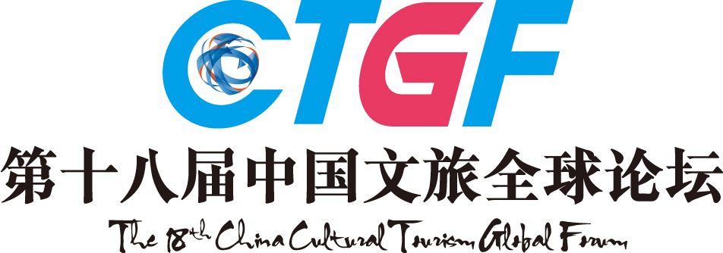

2017 - 2018
THE 18TH CHINA HOTEL GOLDEN HORSE AWARD
Awards List (Hotels)
Applicant: _____________________________________________

Hotels Awards | Hotel Group / Hotel Management Company ( 2017- 2018)  □Most Favored International Brand Hotel Group by Customers  □Most Favored National Brand Hotel Group by Customers  □Top 10 International Hotel Management Companies  □Top 10 National Hotel Management Companies  □Best Non-standard Accommodation Operator of China  □Best Service Apartment Operator of China  □Best Boutique Hotel Group of China  □China’s Most Favored Budget Hotel Group by Customers  □Top Choice of International Hotel Management Company for Investors  □Top Choice of National Hotel Management Company for Investors  □Best Hotel Investor/Owner of China  □Most Potential Hotel Group/Management Company of China  □Best Employer of China Hotel Industry  □Best CSR Investor/ Operator of China Hotel Industry  □Best Potential Cultural Tourism Group/Enterprise  □Best Cultural Tourism Real Estate Investor/Operator  Other Ad Hoc Title:_____________________________________________
Hotels Awards | Hotel Brand Awards (2017- 2018)  □Best Leading Brand of Theme Hotel in China  □Best Leading Brand of Boutique Hotel in China  □Most Valuable Investment Hotel Brand of China  □Hotel “Internet Plus” Landmark Enterprise of China  □Nova Hotel Brand of China  □Top Ten Popular B & B Brands Online  □Most Potential Investment Chain B & B Brand  □Best Creative Cultural Tourism Brand of China  Other Ad Hoc Title:_____________________________________________
Hotels Awards | Independent Hotels Awards (2017- 2018)  (1) TOP 100 HOTELS OF CHINA  □Top Choice for International Business Travelers  □Top Choice for National Business Travelers  □City Landmark Hotel  □China’s Most Satisfactory Hotel by Customers  □Best Natural Environmental View Hotel of China  □Best Environmentally Friendly Hotel of China  □Best Cultural Theme Hotel of China  □Best Designed Boutique Hotel of China  □Best Technological Design Hotel of China  □Best Construction Design Hotel of China  □Best Creative Design Hotel of China  □Best Excellent Service Hotel of China  □Best Parent-Child Hotel of China  □Most Luxury Hotel of China  □Best Business Hotel of China  □Best MICE Hotel of China  □Best Hot Spring Resort Hotel of China  □Best Resort Hotel of China  □Best Golf Hotel of China  □Best Service Apartment of China  □Most Glamorous Hotel of China  □Best Wedding Hotel of China  □Best City Boutique Hotel of China  □Best Tourist Destination Hotel of China  □Best Urban Nova Hotel of China  □Most Anticipated Newly-opened Hotel of China  □Most Potential Newly-Opened Hotel of China  □Best Life Aesthetics Hotel of China  □Best Boutique B & B of China  (2)A BITE OF CHINA STYLE AWARDS（Or Apply for Other Ad Hoc Title According to Your Own Characteristics)  □A Bite of China Sichuan Cuisine Famous Restaurant  □A Bite of China Cantonese Cuisine Famous Restaurant  □A Bite of China Hunan Cuisine Famous Restaurant  □A Bite of China Legacy Award  □A Bite of China Creativity Award  □Others  (3) THE SUPREME AWARDS（Or Apply for Other Ad Hoc Title According to Your Own Characteristics)  □The Supreme Glamorous Business Hotel of China  □The Supreme Tourism Complex of China  □The Supreme Most Anticipated Newly-opened Hotel of China  Other Ad Hoc Title:_____________________________________________
Hotels Awards | Figure Awards(2017- 2018)  - China Hotel Elites List---Top 100 Figures of the Year  □Lifetime Achievement Honor  □Top 10 Influential Figures of China Hotel Industry of the Year  □Five-Star Elite  □Platinum Elite  (2) Comprehensive Award (2017– 2018)  □Best President of China Hotel Industry  □New Leading Hotelier of China  □China’s Influential Figure of Cultural Tourism of the Year  □Best Owner’s Representative of China Hotel Industry  □Best General Manager of China Hotel Industry  □Best Mar-com Figure of China Hotel Industry  □Platinum Professional Manager of China Hotel Industry  □Management Master of China Hotel Industry  □Planning Master of China Hotel Industry  □Golden Award of Cultural Tourism Real Estate Trader  □Top 10 Chefs of China □Golden Spoon Chef of China  □Platinum Chef of China □Gold Medal Chef of China  Other Ad Hoc Title:_____________________________________________
Hotels Awards | Cuisine Award (2017- 2018)  □Famous Chinese Cuisine □Famous Chinese Snack □Famous Chinese Dim-sum  Other Ad Hoc Title:____________________________________________
Note：Please mark “√” in the form to select the award you want to apply for.

The 18th China Hotel Industry Golden Horse Awards Ceremony

Inspired by the excellent China Tourism City logo, which is a horse stepping on a flying swallow, China Hotel Golden Horse Award chooses the same image as the award shape to symbolize the highest honor of China Hotel Industry, initiated by Mr. Liu Yi, former Director of National Tourism Administration. With 18 years of continuous influences, China Hotel Golden Horse Award has gained wide recognition and high reputation, and the winner of which would be regarded as the benchmark of the industries.

Still referring the international selection tradition, the 18th China Hotel Golden Horse Awards will be selected and produced from the finalists of cultural tourism & Hotels, top 100 catering enterprises, top 100 partners of 2017-2018(including manufacturers, service providers, suppliers, hotel design agencies) of industry chain, China featured tourism towns, boutique hotels, ecological farms, as well as Top 100 Influence Elites of China Hotel Industry of 2017-2018. For individuals or enterprises that meet the above requirements, please submit application materials and the application form (see the attachment).

Key Dates for the Award
Submission: From October 9th, 2017
Awards Announcement: March 22nd, 2018
Award Ceremony: March 22nd, 2018

4. The Selection Process
Stage 1: Nominee Recommendation
The nominees are recommended by their governmental competent departments. Taking the international selection tradition, the portion of nominees and winner is 5:1.
Stage 2: Nomination Notice
Nominees will receive the nomination notice from the organizing committee.
Stage 3: Submission of Materials
Nominees should submit necessary materials in time.
Stage 4: Primary Selection
The primary list is made according to submitted materials.
Stage 5: Evaluation of Experts
The evaluation of experts, held by Tourism Research Center of CASS and China Career Research Center of Peking University, accounts for 30% of the result.
Stage 6: Public Voting
Public voting is available on official website, partner media, Weibo, WeChat and SMS, which accounts for 20% of the result.
Stage 7: Golden Horse VIP Experience
Entrip, Chief New Media of China's Cultural Tourism Industry, will select some VIPs who have consumed in the contestant cultural tourism complex, hotels or restaurants, which accounts for 20% of the result.
Stage 8: Judge Panel's Voting
The authoritative judge panel will have a comprehensive evaluation on the nominated list, which accounts for 30% of the result.
Stage 9: Vote Counts
The final result will be made by the organizing committee through comprehensive evaluation.
Stage 10: Award Notice
Awarding notice will be sent by the organizing committee.
Stage 11: Award Ceremony
The award ceremony will be held during the 18th China Cultural Tourism Global Forum. Related certificates and prize medals will be awarded to winners.
Stage 12: Mass Promotion
Final list will be announced on mainstream media, promoting the winners of awards.

Contacts:
For more information, please check in our official website: www.CTGF163.com or call 020-89899000.

