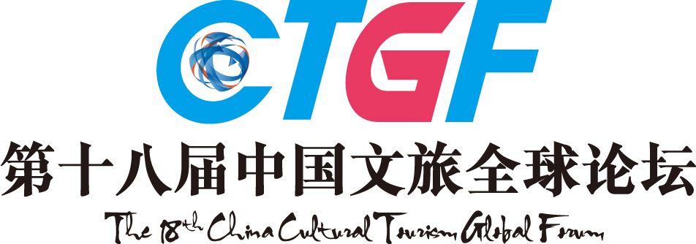

2017 - 2018
THE 18TH CHINA HOTEL GOLDEN HORSE AWARD
Awards List (Real Estate / Design Agencies)
Applicant:_____________________________________________
Real Estate | Commercial Real Estate Awards (2017 – 2018)：  □City Landmark of Commercial Real Estate Project of China  □New City Symbol of Commercial Real Estate Project of China  □Leading Experience Commercial Real Estate Project of China  □Best ROI Commercial Real Estate Project of China  □Best Format Planning Commercial Real Estate Project of China  □Best Operating & Management Commercial Project of China  □Best City Catering Landmark Operator of China  □Best Catering Investment Commercial Real Estate Project of China  □Most Distinctive Food City/Food Court of China  □Best Themed Creative Food City/Food Court of China  Other Ad Hoc Title:_____________________________________________
Real Estate | Tourism Real Estate Awards (2017 – 2018)：  □Top Ten Distinctive Sojourn Towns of China  □Best Timeshare Tourism Real Estate Project of China  □Best Cultural Tourism Town of China  □Most Anticipated New Cultural Tourism Project of the Year  □Most Potential Investment Resort of China  □Excellent Cultural Tourism Projects of “the Belt and Road Initiatives”  □Best Cultural Tourism Theme Resort of China  □Best Cultural Tourism Theme Park of China  Other Ad Hoc Title:_____________________________________________
Design Agencies | Design Agency Awards (2017 – 2018)  (1)Comprehensive Awards  □Best Cultural Tourism Real Estate Design Agency of China  □Golden Award of Best Cultural Tourism Complex Design of China  □Best Original Cultural Tourism Design Agency of China  □Best Original Catering Design Agency of China  □Best Original Hotel Design Agency of China  □Best Cultural & Creative Hotel Design Agency of China  □Meritorious Design Promoter of China Hotel Industry  □Leading Hotel Design Brand of China  □Most Competitive Hotel Design Agency of China  □Most Potential Hotel Design Agency of China  □Best VI Design Agency of China Hotel Industry  □Best Hotel Soft Outfit Design of China  □Best Hotel Lighting Design Agency of China  Other Ad Hoc Title:_____________________________________________  (2)Design Case Awards  □Golden Award of Best Cultural Tourism Town of China  □Golden Award of Best Characteristic B & B Design of China  □Golden Award of City Landmark Hotel Design of China  □Golden Award of Best Themed Hotel Design of China  □Golden Award of Best Boutique Hotel Design of China  □Golden Award of Best Cultural Hotel Design of China  □Golden Award of Best Service Apartment Design of China  □Golden Award of Best Environmentally Friendly Hotel Design of China  □Golden Award of Best Low-carbon Hotel Design of China  □Golden Award of Best Hotel Lobby Design of China  □Golden Award of Best Presidential Suite Design of China  □Golden Award of Best Hotel Landscape Design of China  □Golden Award of Best Hotel Aesthetic Design of China  □Golden Award of Best Hotel Lighting Design of China  □Golden Award of Best Creative Restaurant Design of China  Other Ad Hoc Title:_____________________________________________  (3)The Supreme Awards (Only One Award in Each Title)  □ The Supreme Original Hotel Design of China  □The Supreme Original Restaurant Design of China  □The Supreme Cultural & Creative Real Estate Design of China  Other Ad Hoc Title:_____________________________________________
Design Agencies | (4)Figure Awards  □Leading Cultural & Creative Real Estate Designer of China  □Leading Hotel Designer of China  □China’s Influential Hotel Designer of the Year  □Platinum Original Hotel Designer of China  □Nova Hotel Designer of China  Other Ad Hoc Title:_____________________________________________
Note：Please mark “√” in the form to select the award you want to apply for.

The 18th China Hotel Industry Golden Horse Awards Ceremony

Inspired by the excellent China Tourism City logo, which is a horse stepping on a flying swallow, China Hotel Golden Horse Award chooses the same image as the award shape to symbolize the highest honor of China Hotel Industry, initiated by Mr. Liu Yi, former Director of National Tourism Administration. With 18 years of continuous influences, China Hotel Golden Horse Award has gained wide recognition and high reputation, and the winner of which would be regarded as the benchmark of the industries.

Still referring the international selection tradition, the 18th China Hotel Golden Horse Awards will be selected and produced from the finalists of cultural tourism & Hotels, top 100 catering enterprises, top 100 partners of 2017-2018(including manufacturers, service providers, suppliers, hotel design agencies) of industry chain, China featured tourism towns, boutique hotels, ecological farms, as well as Top 100 Influence Elites of China Hotel Industry of 2017-2018. For individuals or enterprises that meet the above requirements, please submit application materials and the application form (see the attachment).

Key Dates for the Award
Submission: From October 9th, 2017
Awards Announcement: March 22nd, 2018
Award Ceremony: March 22nd, 2018

4. The Selection Process
Stage 1: Nominee Recommendation
The nominees are recommended by their governmental competent departments. Taking the international selection tradition, the portion of nominees and winner is 5:1.
Stage 2: Nomination Notice
Nominees will receive the nomination notice from the organizing committee.
Stage 3: Submission of Materials
Nominees should submit necessary materials in time.
Stage 4: Primary Selection
The primary list is made according to submitted materials.
Stage 5: Evaluation of Experts
The evaluation of experts, held by Tourism Research Center of CASS and China Career Research Center of Peking University, accounts for 30% of the result.
Stage 6: Public Voting
Public voting is available on official website, partner media, Weibo, WeChat and SMS, which accounts for 20% of the result.
Stage 7: Golden Horse VIP Experience
Entrip, Chief New Media of China's Cultural Tourism Industry, will select some VIPs who have consumed in the contestant cultural tourism complex, hotels or restaurants, which accounts for 20% of the result.
Stage 8: Judge Panel's Voting
The authoritative judge panel will have a comprehensive evaluation on the nominated list, which accounts for 30% of the result.
Stage 9: Vote Counts
The final result will be made by the organizing committee through comprehensive evaluation.
Stage 10: Award Notice
Awarding notice will be sent by the organizing committee.
Stage 11: Award Ceremony
The award ceremony will be held during the 18th China Cultural Tourism Global Forum. Related certificates and prize medals will be awarded to winners.
Stage 12: Mass Promotion
Final list will be announced on mainstream media, promoting the winners of awards.

Contacts:
For more information, please check in our official website: www.CTGF163.com or call 020-89899000.

