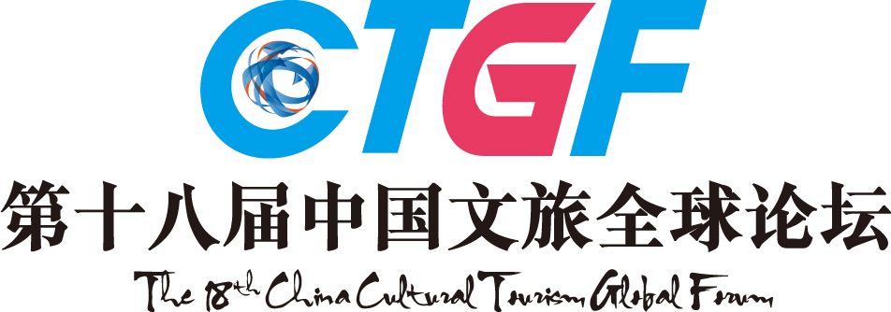
2017 - 2018
THE 18TH CHINA HOTEL GOLDEN HORSE AWARD
Awards List (Suppliers)
Applicant:_____________________________________________
Suppliers | Enterprise Group Awards (Awarded by APHA)  □The APHA Appointed / Recommended One-stop Sourcing Base  □The APHA Recommended Best Hotel Article City  □The APHA Recommended E-commerce Purchasing Platform  □The APHA Recommended Gold Supplier  Other Ad Hoc Title:_____________________________________________
Suppliers | Top 100 Suppliers Awards (2017 – 2018)  □Best Hotel Management &IT Integration Solutions Service Provider of China  □Best Hotel Internet Marketing Solutions Service Provider of China  □Best Smart Hotel Operation Solutions Service Provider of China  □Best CMS Supplier of China  □Best Hotel Swimming Equipment Suppliers of China  □Best Hotel Control Panels and System Suppliers of China  □Best Hotel Stone Suppliers of China  □Best Hotel Video Security System Supplier of China  □Best Hotel Furniture Supplier of China  □Best Hotel Lighting Supplier of China  □Best Hotel Bathing Equipment Supplier of China  □Best Hotel Spa Equipment Supplier of China  □Best Hotel Audio & Video Supplier of China  □Best Hotel Smart Lock Supplier of China  □Best Hotel Washing Equipment Supplier of China  □Best Hotel Ceramics Supplier of China  □Best Hotel Wooden Floor Supplier of China  □Best Hotel Uniform Supplier of China  □Best Hotel Carpet Supplier of China  □Best Hotel Linen Supplier of China  □Best Hotel Fitness Equipment Supplier of China  □Best Hotel Gift Planning & Production Service Provider of China  □Best Wedding Photography & Planning Service Provider of China  □Best Conference / Exhibition Planning Service Provider of China  □Best Bakery Equipment Supplier of China □Best Kitchenware Supplier of China  □Best Tableware Supplier of China □Best Electric Table Supplier of China  □Best Ordering System Supplier of China □Best Mooncake OEM Supplier of China  □Best Dried Seafood Supplier of China □Best Seafood Supplier of China  □Best Condiment Supplier of China □Best Wine Supplier of China  □Best Western Spirit Supplier of China □Best White Wine Supplier of China  □Best Green Beverage Supplier of China □Best Tea Supplier of China  □Best Coffee Supplier of China □Best Dairy Product Supplier of China  Other Ad Hoc Title:_____________________________________________
Suppliers | Figure Awards  □Economic Figure of the Year □Industry Development Meritorious Promoter of the Year  □Most Influential Figure of the Year  Other Ad Hoc Title:_____________________________________________
Note：Please mark “√” in the form to select the award you want to apply for.
The 18th China Hotel Industry Golden Horse Awards Ceremony

Inspired by the excellent China Tourism City logo, which is a horse stepping on a flying swallow, China Hotel Golden Horse Award chooses the same image as the award shape to symbolize the highest honor of China Hotel Industry, initiated by Mr. Liu Yi, former Director of National Tourism Administration. With 18 years of continuous influences, China Hotel Golden Horse Award has gained wide recognition and high reputation, and the winner of which would be regarded as the benchmark of the industries.

Still referring the international selection tradition, the 18th China Hotel Golden Horse Awards will be selected and produced from the finalists of cultural tourism & Hotels, top 100 catering enterprises, top 100 partners of 2017-2018(including manufacturers, service providers, suppliers, hotel design agencies) of industry chain, China featured tourism towns, boutique hotels, ecological farms, as well as Top 100 Influence Elites of China Hotel Industry of 2017-2018. For individuals or enterprises that meet the above requirements, please submit application materials and the application form (see the attachment).

Key Dates for the Award
Submission: From October 9th, 2017
Awards Announcement: March 22nd, 2018
Award Ceremony: March 22nd, 2018

4. The Selection Process
Stage 1: Nominee Recommendation
The nominees are recommended by their governmental competent departments. Taking the international selection tradition, the portion of nominees and winner is 5:1.
Stage 2: Nomination Notice
Nominees will receive the nomination notice from the organizing committee.
Stage 3: Submission of Materials
Nominees should submit necessary materials in time.
Stage 4: Primary Selection
The primary list is made according to submitted materials.
Stage 5: Evaluation of Experts
The evaluation of experts, held by Tourism Research Center of CASS and China Career Research Center of Peking University, accounts for 30% of the result.
Stage 6: Public Voting
Public voting is available on official website, partner media, Weibo, WeChat and SMS, which accounts for 20% of the result.
Stage 7: Golden Horse VIP Experience
Entrip, Chief New Media of China's Cultural Tourism Industry, will select some VIPs who have consumed in the contestant cultural tourism complex, hotels or restaurants, which accounts for 20% of the result.
Stage 8: Judge Panel's Voting
The authoritative judge panel will have a comprehensive evaluation on the nominated list, which accounts for 30% of the result.
Stage 9: Vote Counts
The final result will be made by the organizing committee through comprehensive evaluation.
Stage 10: Award Notice
Awarding notice will be sent by the organizing committee.
Stage 11: Award Ceremony
The award ceremony will be held during the 18th China Cultural Tourism Global Forum. Related certificates and prize medals will be awarded to winners.
Stage 12: Mass Promotion
Final list will be announced on mainstream media, promoting the winners of awards.

Contacts:
For more information, please check in our official website: www.CTGF163.com or call 020-89899000.

